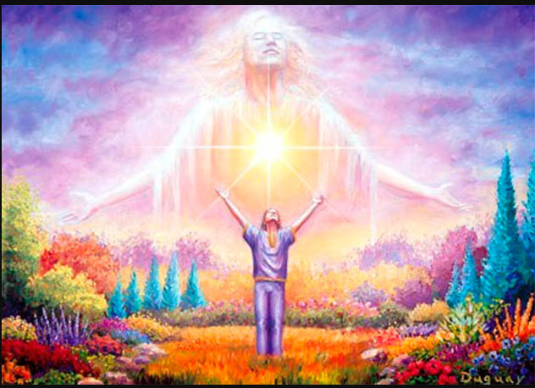

Belief Healing Transmutation Work Sheet

Note: You can type your answers directly into this work sheet

Step #1
Answer these questions for each belief that you would like to shift from a self-limiting belief to a self-supporting belief. The results will be that you will align your mind and emotions with the desired changes that you wish to live. The result will be that you will find it easier to move forward in your preferred life directions:

1. Write down a belief that you want to transmute from being a limiting belief that is slowing down or thwarting your goals to transform into a belief that supports your preferred life experiences and goals success

2. How does this belief negatively impact your life? Example: what does this belief prevent you from having in your life, prevent you from doing in your life, and how does this belief prevent you from being the kind of person that you want to be?

3. When you change this self-limiting belief so that you are enhanced rather than suppressed, what desirable, self-enhancing, useful internal abilities and inner states will you have access to that reside within you? Example: perhaps you will have access to courage, motivation, positive expectations regarding the outcomes of your goals.

4. What will occur by changing this self-limiting belief to a self-supporting belief? What will this new positive belief allow you to accomplish and create in your world? What will you see yourself doing in your world? What will be able to occur in your life?

5. Describe the life circumstances where these new abilities, new inner states, and positive internal resources will be useful to you once you change to a self-supporting belief. Describe the scenarios that will emerge through your behavior as a result of you being influenced by your access to your new abilities, internal resources, and inner states.

Step #2

Create a multi-sensory visualization where you experience yourself transforming from the person who has been suffering and challenged by your selected limiting belief into that person who has transmuted the negativity into skills, abilities, wisdom, power, and creativity in your world. See yourself successfully pursuing the life that you long to live in all areas of your life.
In this visualization, you will also call upon your spirit guides to help you accomplish the goals that are working on in your visualization. As always, please set the energy where only those beings who are from the vibration of “Love or Above,” who are here for you highest good, and who come from God’s Divine Love and Healing energies. Then, call upon your spirit guides in any capacity that you desire.
You can use these pages to journal your experiences, insights, intuitive guidance, accomplishments, actions plans, and new learnings gained from igniting this internal visualization movie

________________________________________________________________________________________________________________________________________________________________________________________________________________________________________________________________________________________________________________________________________________________________________________________________________________________________________________________________________________________________________________________________________________________________________________________________________________________________________________________________________________________________________________________________________________________________________________________________________________________________________________________________________________________________________________________________________________________________________________________________________________________________________________________________________________________________________________________________________________________________________________________________________________________________________________________________________________________________________________________________________________________________________________________________________________________________________________________________________________________________________________________________________________________________________________________________________________________________________________________________________________________________________________________________________________________________________________________________________________________________________________________________________________________________________________________________________________________________________________________________________________________________________________________________________________________________________________________________________________________________________________________________________________________________________________________________________________________________________________________________________________________________________________________________________________________________________________________________________________________________________________________________________________________________________________________________________________________
__________________________________________________________________________________________________________________________________________________________________________________________________________________________________________________________________________________________________________________________________________________________________________________________________________________________________________________________________________________________________________________________________________________________________________________________________________________________________________________________________________________________________________________________________________________________________________________________________
__________________________________________________________________________________________________________________________________________________________________________________________________________________________________________________________________________________________________________________________________________________________________________________________________________________________________________________________________________________________________________________________________________________________________________________________________________________________________________________________________________________________________________________________________________________________________________________________________
__________________________________________________________________________________________________________________________________________________________________________________________________________________________________________________________________________________________________________________________________________________________________________________________________________________________________________________________________________________________________________________________________________________________________________________________________________________________________________________________________________________________________________________________________________________________________________________________________
________________________________________________________________________________________________________________________________________________________________________________________________________________________________________________________________________________________________________________________________________________________________________________________________________________________________________________________________________________________________________________________________________________________________________________________________________________________________________________________________________________________________________________________________________________________________________________________________________________________________________________________________________________________________________________________________________________________________________________________________________________________________________________________________________________________________________________________________________________________________________________________________________________________________________________________________________________________________________________________________________________________________________________________________________________________________________________________________________________________________________________________________________________________________________________________________________________________________________________________________________________________________________________________________________________________________________________________________________________________________________________________________________________________________________________________________________________________________________________________________________________________________________________________________________________________________________________________________________________________________________________________________________________________________________________________________________________________________________________________________________________________________________________________________________________________________________________________________________________________________________________________________________________________________________________________________________________________
____________________________________________________________________________________________________________________________________________________________________________________________________________________________________________________________________________________________________________________________________________________________________________________________________________________________________________________________________________________________________________________________________________________________________________________________________________________________________________________________________________________________________________________________

